UNIVERSITY OF TECHNOLOGY JAMAICA

Prolog Group Project

Dacorie Smith

Maurice Mccrea

Luke Molland

Rosue Walford

Project Description

N. Maitland

Group Size: 4

**Given: Week of February 9, 2015 Due: Thursday March 26, 2015**

The Ministry of National Security (MNS) has a crime program that is aimed at apprehending and aiding in the prosecution of criminals. In a press release MNS emphasized that effective control of crime depends primarily on identifying criminals and this can be aided by vigilant citizens. Once you identify a suspect timely reporting of these suspects could help the Police in appending these criminals and taking them to court to be charged and sentenced. The MNS spoke about collaboration between the University of Technology Jamaica (UTECH) and the ministry to build an Expert System to assist the police and citizens alike in identifying these criminal suspects.

The proposed Expert system will be populated with various human characteristics such as (colour of eyes, skin colour, height, special marks (scars etc)). These characteristics will be entered in the system; this should allow a combination of at least three different characteristics before positive identification. You may also create your own additional characteristics. The information will be gathered by a team of experts from UTECH these four individuals will be contracted to meet with domain experts and use the data gathered to design and implement the system prototype.

According to a press release a demonstration of the system is scheduled for Thursday March 26, 2015 at 9 am at the UTECH campus in Lab C. This system will be used to identify the criminal suspects. The prototype should be able to accept details for additional characteristics where necessary.

Requirements :-

Students should work in groups of four (4) unless permission is granted. As stated above the team is required to build an expert system using PROLOG/ to positively identify criminal suspects. The group should present the completed program along with commented code and project documentation.

The expert system should provide its users with an interface that allows them to interact with the system.

The set of questions the expert system will ask should be guided by the input of the domain experts and they should be placed in the knowledge base. The domain experts should provide sufficient detail so the expert system can determine if the individual is positively identified or to what extent the information can identify the suspect and what additional information is required to complete the process of identification.

You are required to submit the complete source code, and documentation. The documentation should include the following: **System Design**, **User Manual** and **Project Group Report** (highlighting the contribution of each member and lessons learnt) on a CD by March**, 26, 2015**.

# Marking Scheme:

Marks will be awarded as follows:

* Facts (10%)
* Rules (15%)
* Persistence (10%)
* Functionality (30%)
  + Proper use facts and rules [5%]
  + Proper use of prolog search mechanisms [5%]
  + Storing of User Response [5%]
  + Use of User Response in arriving at conclusion / solution [5%]
  + Robustness [5%]
  + Correctness [5%]
* Documentation (15%)
  + Internal : comments, indentation and naming conventions
  + External: hardcopy – formatting, neatness, sample run, group report and declaration of authorship (one per member)
* User Interface & Ease of Use (10%)
* Originality & Ingenuity (10%)

**There will be an additional 10% for groups who provide a grafical user interface (GUI) for this system.**

**Marks will be subtracted for late assignments at a rate of 7.5% per day. Assignments more than one week late will not be accepted.**

**Instruction**

1. Enter Username and password

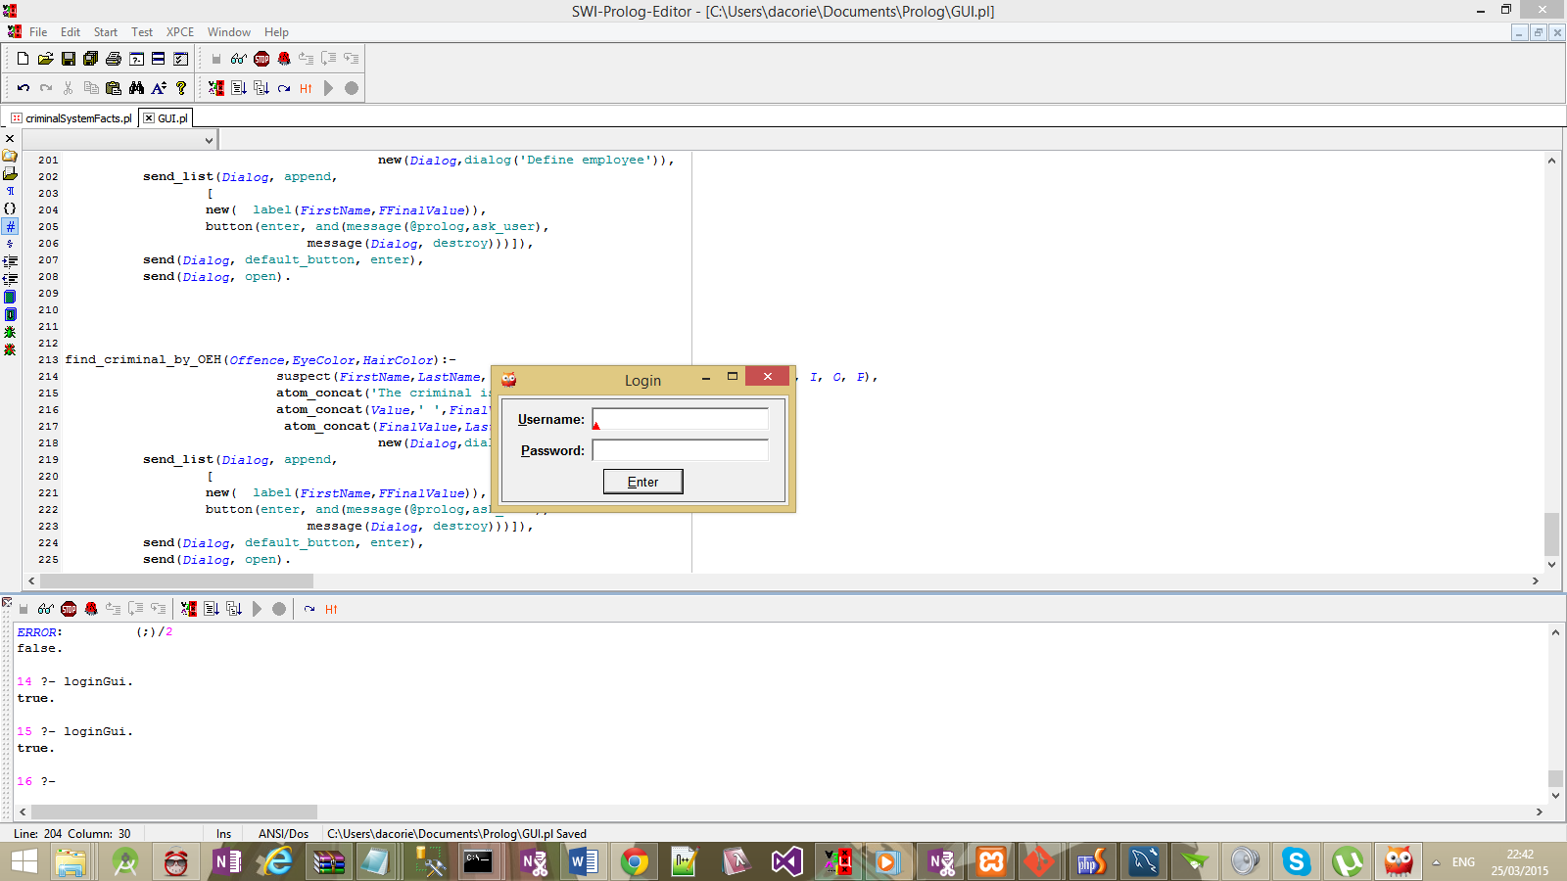

1. Click enter At welcome screen

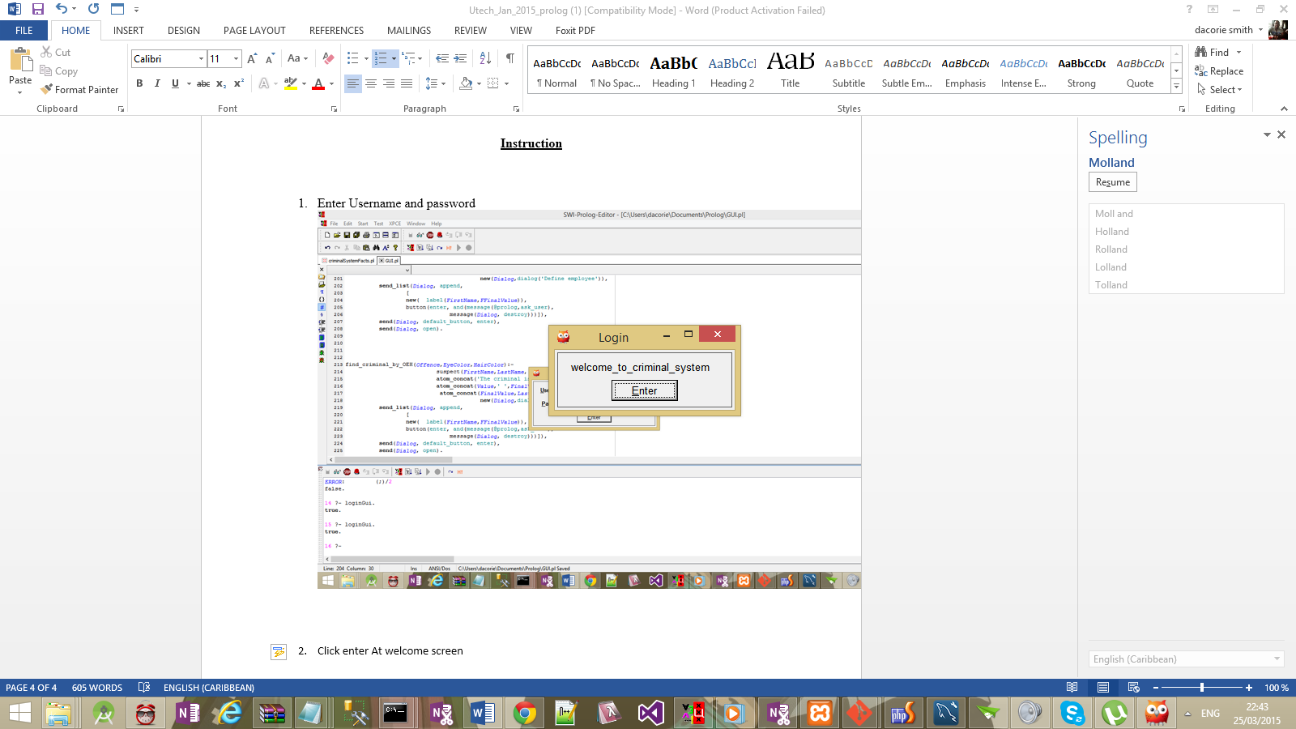

3.Click View all Criminal on the main menu

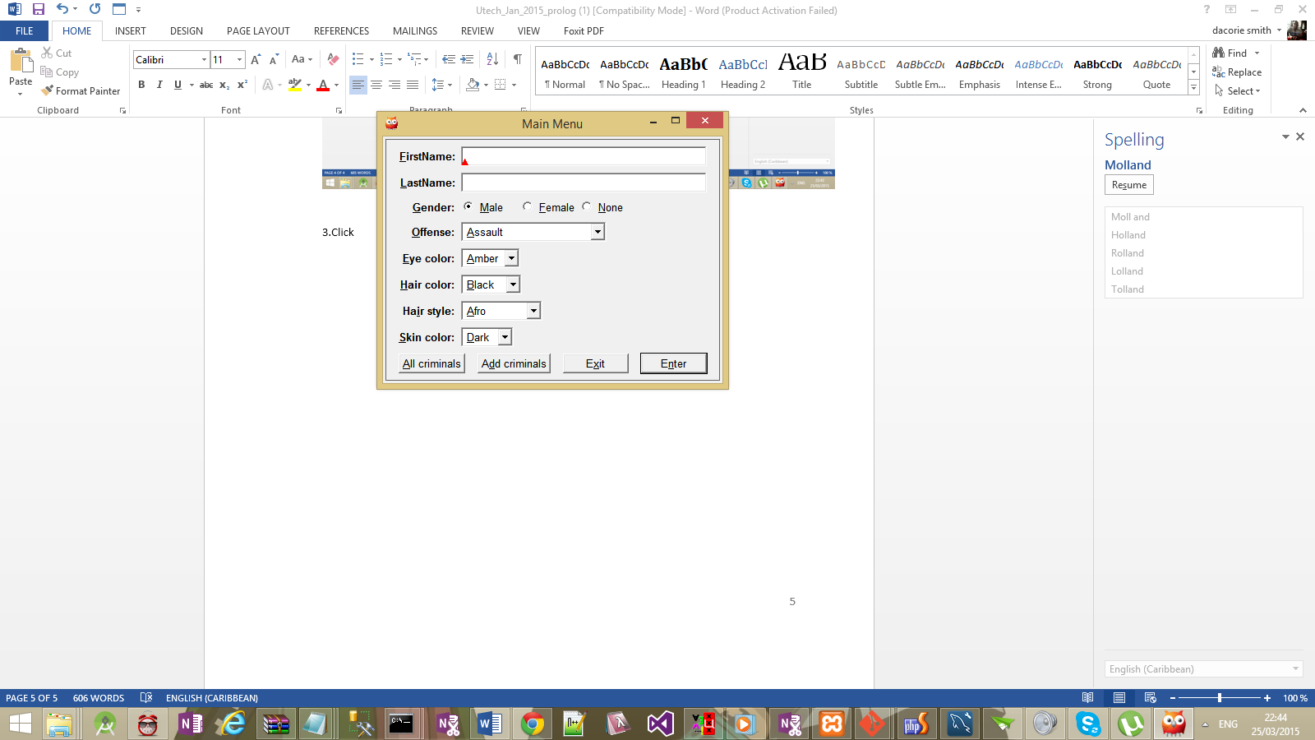

4.View all Criminal and click back to go back to the main menu

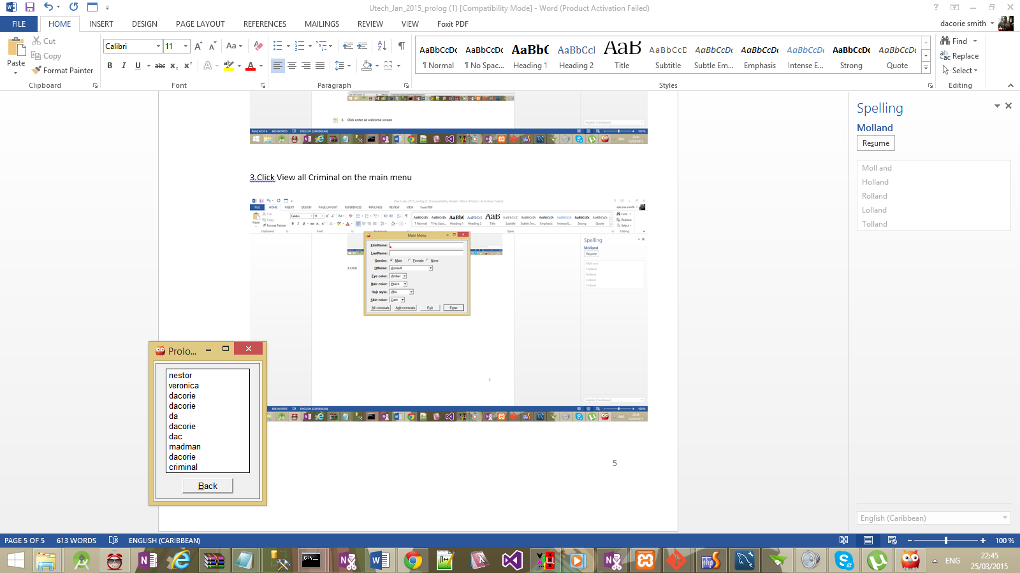

5. Click add records to enter information and fill out fields to add records

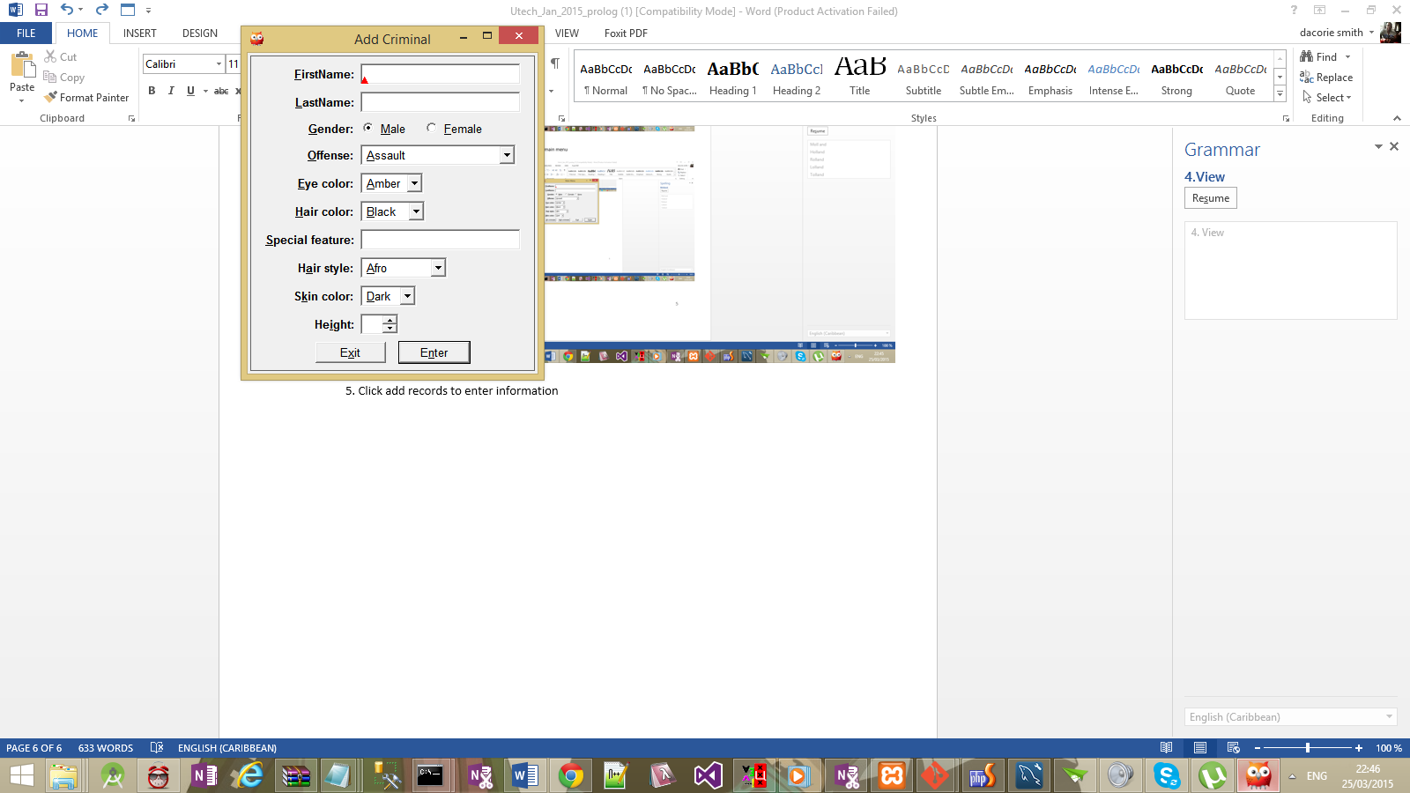

6.Fill out the fields in the main menu to search

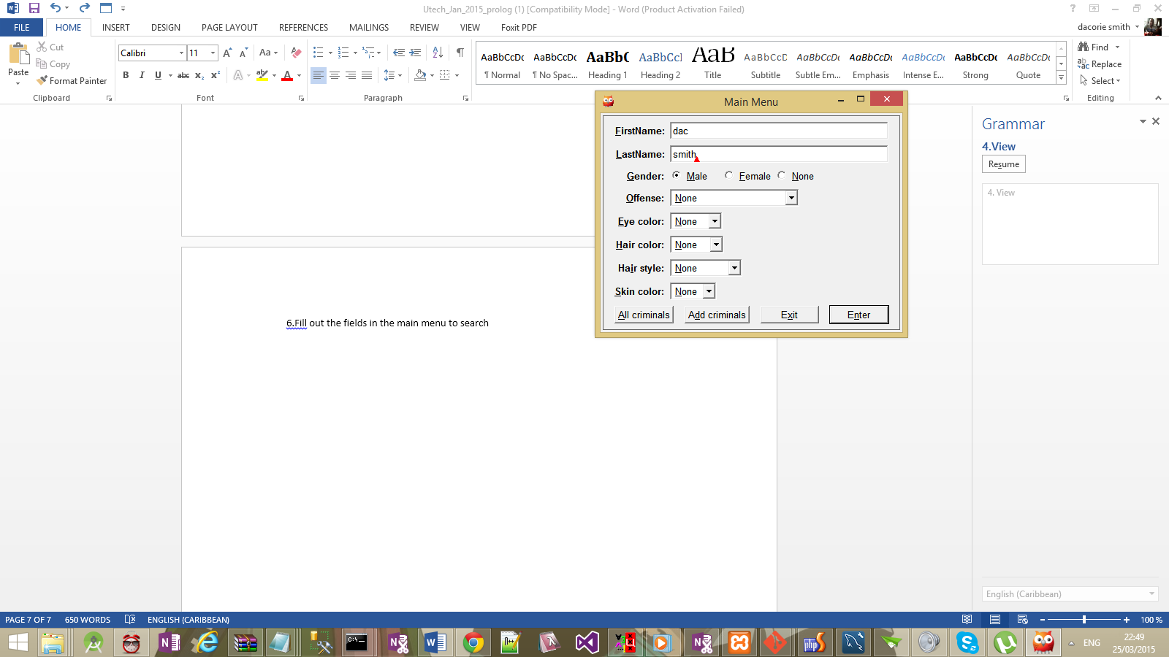

7. Criminal detail will display

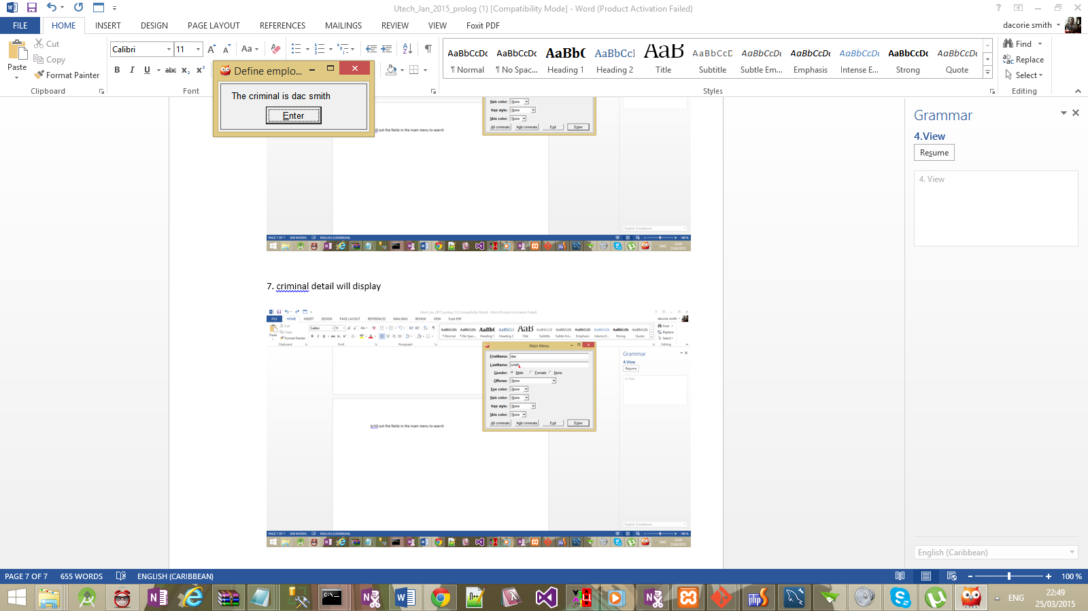

Code:

% Author:

% Date: 3/24/2015

%Common Criminal Charges

offence(assault).

offence(drugs).

offence(theft).

offence(abuse).

offence(computer_crime).

offence(domestic_violence).

offence(indecent_exposure).

offence(kidnapping).

offence(manslaughter).

offence(prostitution).

offence(fraud).

offence(harassment).

offence(homicide).

offence(indecent_exposure).

offence(identity_theft).

offence(kidnapping).

offence(manslaughter_involuntary).

offence(manslaughter_voluntary).

offence(prostitution).

offence(public_intoxication).

offence(rape).

offence(robbery).

offence(sexual_assault).

offence(shoplifting).

offence(none).

%gender (male, female)

gender(male).

gender(female).

gender(none).

%eye color (amber, black, blue, brown, gray, green, hazel, violet)

eye_colour(amber).

eye_colour(black).

eye_colour(blue).

eye_colour(brown).

eye_colour(gray).

eye_colour(hazel).

eye_colour(violet).

eye_colour(none).

%skin color (dark, light)

skin_colour(dark).

skin_colour(light).

skin_colour(none).

%height (ft and inches)

%height(F,Inches).

%weight (pounds)

%special features( tattoo/scars)

special_features(scars).

%hair color (black, brown, red, blonde, )

hair_colour(black).

hair_colour(brown).

hair_colour(red).

hair_colour(blonde).

hair_colour(none).

%hair style(afro, afro textured, etc...)

hair_style(afro).

hair_style(beehiv).

hair_style(big_hair).

hair_style(comb_over).

hair_style(cornrow).

hair_style(dreadlocks).

hair_style(long_hair).

hair_style(mohawk).

hair_style(pony_tail).

hair_style(none).

%populate suspects/known offenders

%human(name, gender, offence,eye colour, hair colour, special features, hair style, skin colur, height, weight)

suspect(nestor,schnabel, male, extortion,eye_colour(blue), hair_colour(brown), special_features('flowers tattoo shoulder'), hair_style(wave), skin_colour(dark), height([5.9])).

% suspect( (freeman), lname(haverty), gender(male), offense(harassment), eye_colour(brown), hair_colour(black), special_features('dragon tattoo chest'), hair_style(mohawk), skin_colour(light), height([5.11])).

% suspect( (darcie), lname(merino), gender(female), offense(forgery), eye_colour(blue), hair_colour(brown), special_features(none), hair_style(comb-over), skin_colour(dark), height([5.6])).

% suspect( (oralia), lname(keplin), gender(female), offense(child-abuse), eye_colour(hazel),hair_colour(black), special_features(none), hair_style(dreadlocks), skin_colour(light), height([5.4])).

% suspect( (erline), lname(vierra), gender(female), offense(prostitution), eye_colour(hazel), hair_colur(blonde), special_features(none), hair_style(long-hair), skin_colour(dark), height([5.3])).

% suspect( (mistie), lanme(rayborn), gender(female), offense(child-abuse), eye_colour(gray), hair_colour(brown), special_features('tatoo on neck'), hair_style(long-hair), skin_colour(dark), height([5.8])).

% suspect( (roslyn),lname(rickman), gender(female), offense(shoplifting), eye_colour(blue), hair_colour(brown), special_features('mole on cheak'), hair_style(cornrow), skin_colour(light), height([5.9])).

% suspect( (kijo), lname(paris), gender(male), offense(domestic-violence), eye_colour(blue), hair_colour(brown), special_features(['heart tattoo shoulder', 'scar left hand']), hair_style(wave), skin_colour(dark), height([5.9])).

% suspect( (antwan), lname(killion), gender(male), offense(identity-theft), eye_colour(grey), hair_colour(black), special_features(none), hair_style(corn-row), skin_colour(dark), height([5.11])).

% suspect( (callie), lname(grever), gender(male), offense(rape), eye_colour(black), hair_colour(brown), special_features(none), hair_style(mohawk), skin_colour(dark), height([5.9])).

% suspect( (omar), lname(james), gender(male), offense(kidnapping), eye_colour(blue), hair_colour(brown), special_features(none), hair_style(wave), skin_colour(light), height([5.7])).

% suspect( (john), lname(brown), gender(male), offense(embezzlement), eye_colour(amber), hair_colour(brown), special_features(none), hair_style(ceaser-cut), skin_colour(dark), height([5.9])).

% suspect( (timmy), lname(williams), gender(male), offense(disorderly-conduct), eye_colour(blue), hair_colour(brown), special_features(none), hair_style(wave), skin_colour(light), height([5.9])).

% suspect( (shane), lname(johnson), gender(male), offense(child-abuse), eye_colour(blue), hair_colour(brown), special_features(none), hair_style(corn-row), skin_colour(dark), height([5.5])).

% suspect( (alwyn), lname(lynch), gender(male), offense(drug-possession), eye_colour(hazel), hair_colour(black), special_features(none), hair_style(afro), skin_colour(light), height([5.4])).

% suspect( (jason), lname(pinnock), gender(male), offense(child-abuse), eye_colour(hazel), hair_colour(red), special_features(none), hair_style(wave), skin_colour(dark), height([6.4])).

% suspect( (patrick), lname(king), gender(male), offense(kidnapping), eye_colour(blue), hair_colour(brown),special_features(none), hair_style(corn-row), skin_colour(light), height([5.6])).

% suspect( (leon), lname(jackson), gender(male), offense(drug-possession), eye_colour(brown), hair_colour(grey), special_features(none), hair_style(wave), skin_colour(dark), height([6.3])).

% suspect( (grevon), lname(wright), gender(male), offense(robbery), eye_colour(black), hair_colour(brown), special_feature(none), hair_style(corn-row), skin_colour(light), height([5.8])).

% suspect( (shamar), lname(pitter), gender(male), offense(robbery), eye_colour(brown), hair_colour(brown), special_features('burn mark on forehead'), hair_style(wave), skin_colour(dark), height([6.4])).

% suspect( (sam), lname(campbell), gender(male), offense(computer-crime), eye_colour(grey), hair_colour(brown), special_features(none), hair_style(corn-row), skin_colour(light), height([5.2])).

% suspect( (anthony), lname(bell), gender(male), offense(child-abuse), eye_colour(blue), hair_colour(brown), special_features(none), hair_style(wave), skin_colour(light), height([6.3])).

% suspect( (callie), lname(grever), gender(male), offense(drug-possession), eye_colour(hazel), hair_colour(brown), special_features(none), hair_style(corn-row), skin_colour(dark), height([5.7])).

% suspect( (emily), lname(condello), gender(female), offense(child-abuse), eye_colour(blue), hair_colour(brown),special_features(none), hair_style(big-hair), skin_colour(light), height([5.5])).

% suspect( tana, lname(rominger), gender(female), offense(identity-theft), eye_colour(amber), hair_colour(black), special_features(none), hair_style(afro), skin_colour(dark), height([5.4])).

% suspect((rozanne), lname(mansour), gender(female), offense(prostitution), eye_colour(grey), hair_colour(black), special_features(none), hair_style(comb-over), skin_colour(light), height([5.3])).

suspect(veronica, tailor, female,child_abuse, black, black, none, beehiv, dark, 5.2).

suspect(dacorie,smith,male,male,black,sd,sasa,sasa,sas,sas).

suspect(dacorie,smith,female,assault,black,brown,fdsf,beehiv,light,10).

suspect(da,ddsadd,male,assault,amber,black,dasd,afro,dark,2).

suspect(dacorie,smith,male,assault,amber,black,dac,afro,dark,3).

suspect(dac,smith,male,assault,amber,black,dacorie,afro,dark,9).

suspect(madman,man,male,theft,amber,brown,scar,beehiv,light,10).

suspect(dacorie,smith,male,theft,amber,black,scar,afro,dark,5).

suspect(criminal,ssss,male,theft,amber,black,sssss,big_hair,dark,8).

% load the file that contains all the external database

:- [criminalSystemFacts].

% user facts to enable the user to log in

user(dac,dacorie).

user(dac101,davaska34).

% login Gui. checks the database to log in

loginGui :- new(Dialog,dialog('Login')),

send_list(Dialog, append,

[

new( UserName, text_item(username)),

new(Password, text_item(password)),

button(enter, and(message(@prolog,

checkUser,

UserName?selection,

Password?selection),

message(Dialog, destroy)

))]),

send(Dialog, default_button, enter),

send(Dialog, open).

% verfies user logging

checkUser(UserName,Password):-user(UserName,Password),

UserName \== Password,

new(Dialog,dialog('Login')),

send_list(Dialog, append,

[

new( label(welcome_to_criminal_system,welcome_to_criminal_system)),

button(enter, and(message(@prolog,

ask_user),

message(Dialog, destroy)

))]),

send(Dialog, default_button, enter),

send(Dialog, open).

% main menu loggin , user can search or select different option

ask_user :-

new(Dialog, dialog('Main Menu')),

all_offence(T),all_eye_color(E),all_skin_colour(Skin),

all_special_features(SP), all_hair_colour(HC) ,all_hair_style(HS),

send_list(Dialog, append,

[ new(N1, text_item(firstName)),

new(N2, text_item(lastName)),

new(N3, new(S, menu(gender))),

new(N4, new(Offense, menu(offense,cycle))),

new(N5 , new(Eye,menu(eye_color,cycle))),

new(N6, new(Hair,menu(hair_color,cycle))),

new(N8, new(HairStyle,menu(hair_style,cycle))),

new(N9, new(Skincolor,menu(skin_color,cycle))),

button(all_criminals,and(message(@prolog,

all_criminals),

message(Dialog, destroy))),

button(add_criminals,and(message(@prolog,add_criminal_gui), message(Dialog, destroy))),

button(exit, message(Dialog, destroy)),

button(enter, and(message(@prolog,

pick_search_algorithm,

N1?selection,

N2?selection,

N3?selection,

N4?selection,

N5?selection,

N6?selection,

N8?selection,

N9?selection),

message(Dialog, destroy)))

]),

send_list(Offense, append,T),

send_list(Eye, append,E),

send_list(Hair, append,HC),

send_list(HairStyle, append,HS),

send_list(Skincolor, append,Skin),

send_list(S, append, [male, female,none]),

send(Dialog, default_button, enter),

send(Dialog, open).

% generate a list of all the criminal from the fact file

all_criminals :-

new(D, dialog('Prolog Source Files')),

send_list(D, append,[ new(B, list_browser),

button(back, and(message(@prolog,

ask_user),

message(D, destroy)))]),

all_suspect(L),

send_list(B, append, L),

send(D, open).

% store new criminal records to the file

store_crinimal(FirstName,LastName,Gender,Offense,EyeColor,HairColor,SpecialFeatures,HairStyle,SkinColor,Height) :-

open('criminalSystemFacts.pl',append,Stream),

write(Stream,'suspect('),write(Stream,FirstName), write(Stream,','),write(Stream,LastName),write(Stream,','),

write(Stream,Gender), write(Stream,','),write(Stream,Offense), write(Stream,','),write(Stream,EyeColor), write(Stream,','),write(Stream,HairColor), write(Stream,','),

write(Stream,SpecialFeatures), write(Stream,','),write(Stream,HairStyle), write(Stream,','),write(Stream,SkinColor),write(Stream,','),

write(Stream,Height),

write(Stream,').'),

nl(Stream),

close(Stream),

consult('criminalSystemFacts.pl'),

ask_user.

add_criminal_gui :-

new(Dialog, dialog('Add Criminal')),

all_offence(T),all_eye_color(E),all_skin_colour(Skin),

all_special_features(SP), all_hair_colour(HC) ,all_hair_style(HS),

send_list(Dialog, append,

[ new(N1, text_item(firstName)),

new(N2, text_item(lastName)),

new(N3, new(S, menu(gender))),

new(N4, new(Offense, menu(offense,cycle))),

new(N5 , new(Eye,menu(eye_color,cycle))),

new(N6, new(Hair,menu(hair_color,cycle))),

new(N7, text_item(special_feature)),

new(N8, new(HairStyle,menu(hair_style,cycle))),

new(N9, new(Skincolor,menu(skin_color,cycle))),

new(N10, int_item(height, low := 0, high := 10)),

button(exit, and(message(@prolog,

ask_user),

message(Dialog, destroy))),

button(enter, and(message(@prolog,

store_crinimal,

N1?selection,

N2?selection,

N3?selection,

N4?selection,

N5?selection,

N6?selection,

N7?selection,

N8?selection,

N9?selection,

N10?selection),

message(Dialog, destroy)))

]),

send_list(Offense, append,T),

send_list(Eye, append,E),

send_list(Hair, append,HC),

send_list(HairStyle, append,HS),

send_list(Skincolor, append,Skin),

send_list(S, append, [male, female]),

send(Dialog, default_button, enter),

send(Dialog, open).

result(Value):-

new(Dialog,dialog('Define employee')),

send_list(Dialog, append,

[

new( label(Value,Value)),

button(enter, and(message(@prolog,ask_user),

message(Dialog, destroy)))]),

send(Dialog, default_button, enter),

send(Dialog, open).

assert_employee(FirstName, FamilyName, Sex, Age, Depth,BodyType) :-

format('Adding ~w ~w ~w, age ~w, working at ~w~n',

[ Sex, FirstName, FamilyName, Age, Depth,BodyType]),

result(Age).

% generate all the facts in the database to different list

all_suspect(L) :- findall(A,(suspect(A,S,D,F,G,H,Y,U,Z,M)),L).

all_offence(L) :- findall(S,(offence(S)),L).

all_eye_color(L) :- findall(A,(eye_colour(A)),L).

all_skin_colour(L) :- findall(A,(skin_colour(A)),L).

all_special_features(L) :- findall(A,(special_features(A)),L).

all_hair_colour(L) :- findall(A,(hair_colour(A)),L).

all_hair_style(L) :- findall(A,(hair_style(A)),L).

% deciede which search algorithm to choose

pick_search_algorithm(FirstName,LastName, Gender,Offence, EyeColor, HairColor, HairStyle, SkinColor) :-

Offence == 'none',HairStyle == 'none',

find_criminal_by_fLG(FirstName,LastName, Gender);

Gender == 'none',HairStyle == 'none',

find_criminal_by_OEH(Offence,EyeColor,HairColor).

% the follow predicate generate a criminal based on certain records

find_criminal_by_HSO(HairStyle,SkinColor,Offence):-

suspect(FirstName,LastName, Gender,Offence, EyeColor, HairColor, U, HairStyle, SkinColor, P),

atom_concat('The criminal is ',FirstName,Value),

atom_concat(Value,' ',FinalValue),

atom_concat(FinalValue,LastName,FFinalValue),

new(Dialog,dialog('Define employee')),

send_list(Dialog, append,

[

new( label(FirstName,FFinalValue)),

button(enter, and(message(@prolog,ask_user),

message(Dialog, destroy)))]),

send(Dialog, default_button, enter),

send(Dialog, open).

find_criminal_by_fLG(FirstName,LastName,Gender):-

suspect(FirstName,LastName, Gender,R, T, Y, U, I, O, P),

atom_concat('The criminal is ',FirstName,Value),

atom_concat(Value,' ',FinalValue),

atom_concat(FinalValue,LastName,FFinalValue),

new(Dialog,dialog('Define employee')),

send_list(Dialog, append,

[

new( label(FirstName,FFinalValue)),

button(enter, and(message(@prolog,ask_user),

message(Dialog, destroy)))]),

send(Dialog, default_button, enter),

send(Dialog, open).

find_criminal_by_OEH(Offence,EyeColor,HairColor):-

suspect(FirstName,LastName, Gender,Offence, EyeColor, HairColor, U, I, O, P),

atom_concat('The criminal is ',FirstName,Value),

atom_concat(Value,' ',FinalValue),

atom_concat(FinalValue,LastName,FFinalValue),

new(Dialog,dialog('Define employee')),

send_list(Dialog, append,

[

new( label(FirstName,FFinalValue)),

button(enter, and(message(@prolog,ask_user),

message(Dialog, destroy)))]),

send(Dialog, default_button, enter),

send(Dialog, open).